**DAILY ONLINE ACTIVITIES SUMMARY**

|  |  |  |  |  |  |  |  |  |
| --- | --- | --- | --- | --- | --- | --- | --- | --- |
| **Date:** | **06/06/2020** | | | | | **Name:** | **SUJANA** | |
| **Sem & Sec** | **IV sem & B section** | | | | | **USN:** | **4AL18CS089** | |
| **Online Test Summary** | | | | | | | | |
| **Subject** | | **Data Communication** | | | | | | |
| **Max. Marks** | | **30** | | **Score** | | | **27** | |
| **Certification Course Summary** | | | | | | | | |
| **Course** | **Introduction to Cyber Security** | | | | | | | |
| **Certificate Provider** | | | **Greatlearning academy** | | **Duration** | | | **5.5 hours** |
| **Coding Challenges** | | | | | | | | |
| **Problem Statement1:** Write a program in C to rotate an array by N positions.  **Problem Statement2:** Write a Java Program to find the second-highest number in an array.  **Problem Statement3:** Given an array A of size N containing 0s, 1s, and 2s; you need to sort the array in ascending order. | | | | | | | | |
| **Status: Executed** | | | | | | | | |
| **Uploaded the report in Github** | | | | | **YES** | | | |
| **If yes Repository name** | | | | | **Online-coding** | | | |
| **Uploaded the report in slack** | | | | | **YES** | | | |

Online Test Summary: 18CS46(DC) test was scheduled from 9:30am t0 10:10am .The portion for the IA was 5th module there were 30 questions and the time assigned was 45 minutes the questions were mcq type.

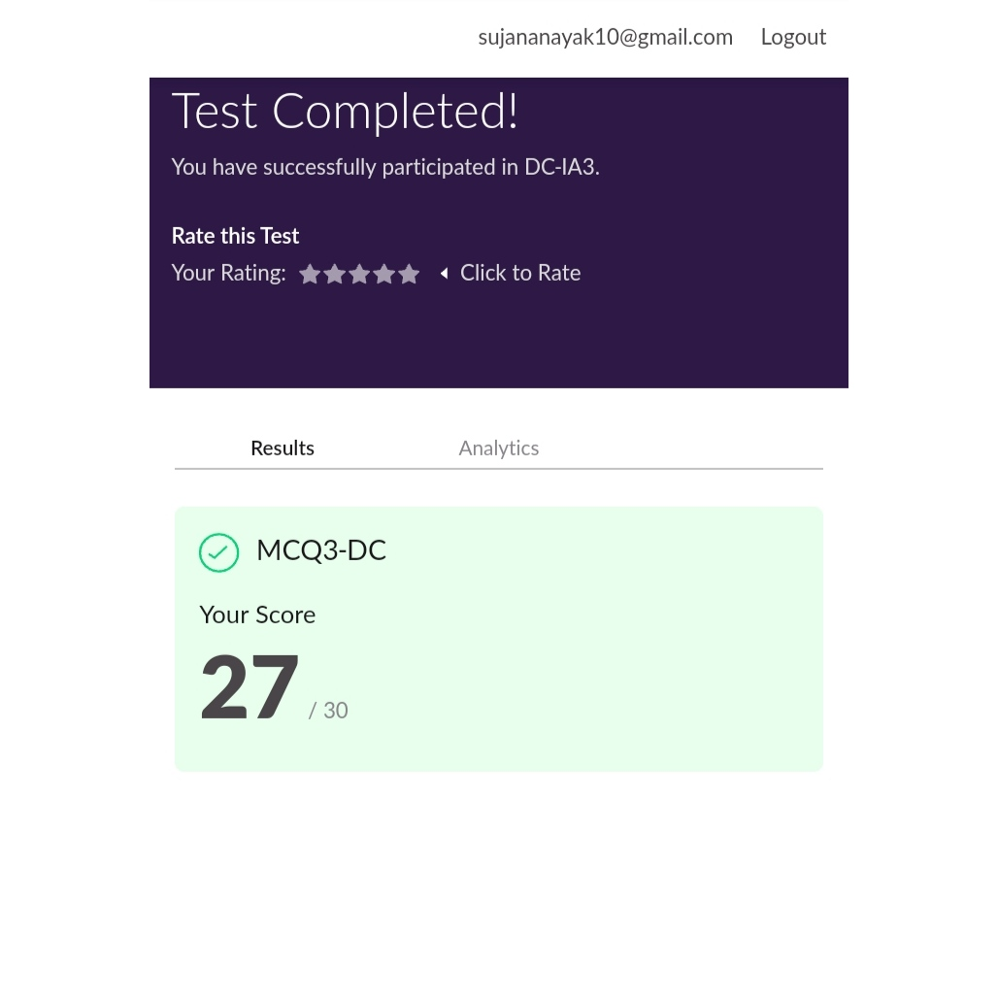

This is the snap shot of completion of test and the marks obtained in 18CS46.

Online Certification Course Summary: Today I have learnt about Secure System Design in Cyber Security, Treats and Vulnerabilities involved in Cyber Security there are many threats and how can it be resolved.

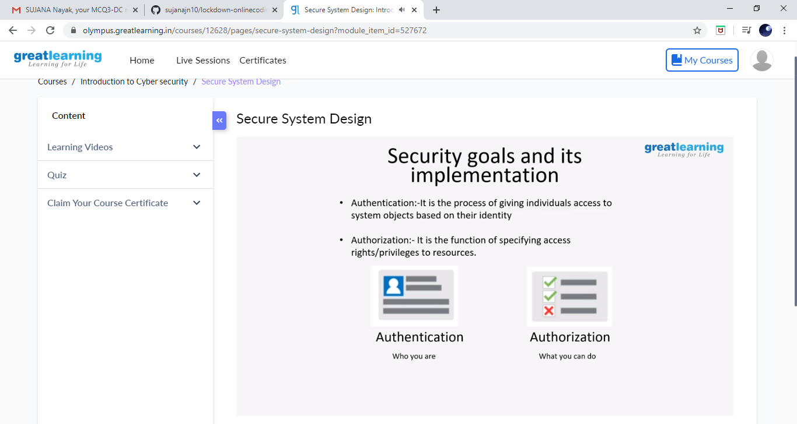

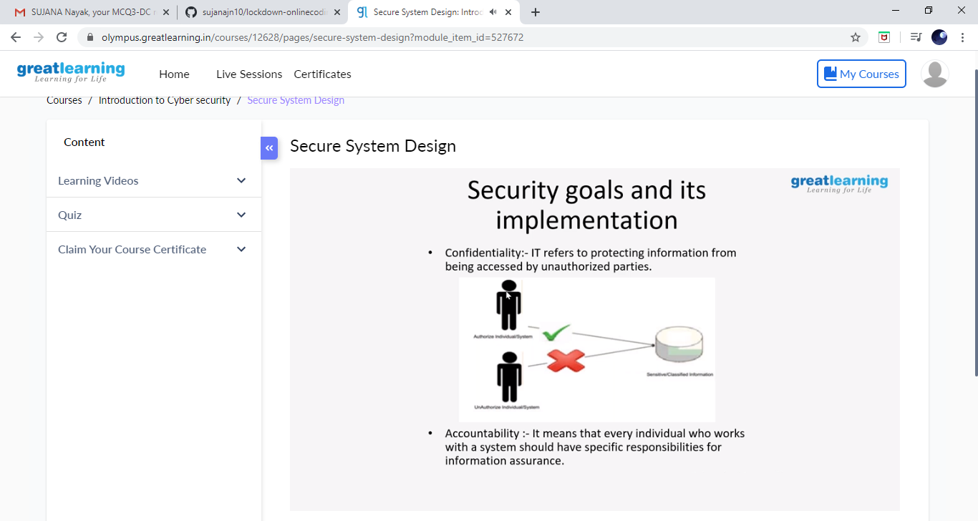

These are the snap shots of today’s session.

Online Coding Summary: **Today I had received one program from prof. Shilpa CSE Dept. the other from Prof. Reena Lobo CSE Dept. and Prof.Venkatesh CSE Dept. The program is mentioned above in the coding challenges. I have also uploaded it to my Github repository.**

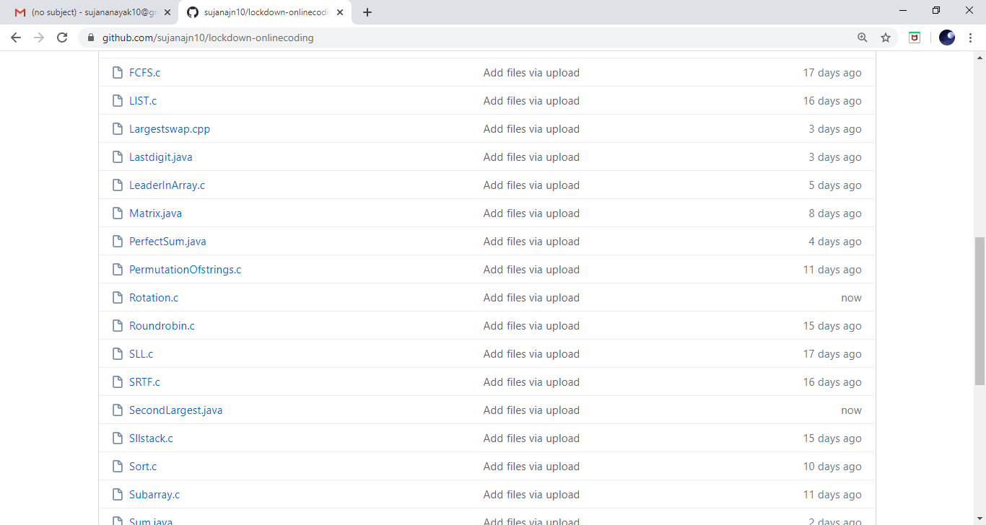

**This is the snap shot of my Github repository** were I have uploaded the code. File name is SecondLargest.java, Count.java and rotation.c